**Supplementary Information**

**Black Phosphorus Nanosheets Inhibit Glioblastoma Cell Migration and Invasion through Modulation of WNT/β-catenin and NOTCH Signaling Pathways**

*Yue Xiong*a*, Chao He*a, b*, Xun Lin*a*,* *Ke Cheng*a*, Fumei He*a*, Jingxin Zhao*a*, Mengjie Yang*a*, Hong Gao*a*, Fangjie He*a*, Xiaopei Zhang*c*, Zeqi Liu*a*, Gan Liu*a, *\*, Wenbin Deng*a, *\**

a School of Pharmaceutical Sciences (Shenzhen), Shenzhen Campus of Sun Yat-sen University, Shenzhen, 518107, China.

b Institute of Biomedical Health Technology and Engineering, Shenzhen Bay Laboratory, Shenzhen, 518132, China.

c Division of Pharmacoengineering and Molecular Pharmaceutics, Eshelman School of Pharmacy, The University of North Carolina at Chapel Hill, Chapel Hill, NC 27588, USA.

* Corresponding authors: Gan Liu (liugan5@mail.sysu.edu.cn), and Wenbin Deng (dengwb5@mail.sysu.edu.cn)

**This Word file includes:**

Figure S1 to S16

Table S1 to S2

**Supplementary Figures**



**Fig. S1** The characterization and anti-proliferation effects on brain cells of BPNS. (**A**) TEM image of BPNS. (**B**) AFM image and its height profiles along the white lines in the AFM image of BPNS. (**C**) The particle size distribution of BPNS. (**D**) The surface charge of BPNS, *n* = 3. (**E**) The results of dispersibility and stability of BPNS in different dispersive systems (H2O, PBS, Complete medium) in different time point. (**F**) The proliferation ability of U87-MG cells, GL261 cells, BV2 cells, and NPC cells after being treated with BPNS for 24 h, *n* = 5. Scale bar: 200 nm.



**Fig. S2** BPNS suppressed the migration of U251-MG cells. (**A**) U251-MG cells were treated with BPNS (0 - 8 μg/mL) to evaluate cell migration ability by wound healing assay. (**B**) The quantitative statistical results of wound area after 24 h. Scale bar: 100 μm. Error bar, mean ± SD, *n* = 3, \**P* < 0.05, \*\**P* < 0.01.



**Fig. S3** The impact of different sizes of BPNS on the migration ability of glioblastoma cells. (A) The size of BPNS obtained from gradient centrifugation at 1000 rpm-4000 rpm (1k-4k) was approximately distributed around 650 nm. (B) The size of BPNS obtained from gradient centrifugation at 4000 rpm-7000 rpm (4k-7k) was approximately distributed around 260 nm. (C) The size of BPNS obtained from gradient centrifugation at 10000 rpm-14000 rpm (10k-14k) was approximately distributed around 190 nm. (D-E) Assessing the impact of BPNS (0 - 8 μg/mL), obtained through centrifugation at 1k-4k rpm, on the migration ability of U87-MG cells via scratch experiments and quantitatively analyzing the experimental results after 48 h. (F-G) Assessing the impact of BPNS (0 - 8 μg/mL), obtained through centrifugation at 4k-7k rpm, on the migration ability of U87-MG cells via scratch experiments and quantitatively analyzing the experimental results after 48 h. (H-I) Assessing the impact of BPNS (0 - 8 μg/mL), obtained through centrifugation at 10k-14k rpm, on the migration ability of U87-MG cells via scratch experiments and quantitatively analyzing the experimental results after 48 h. Scale bar: 100 μm. Error bar, mean ± SD, *n* = 4, \**P* < 0.05, \*\**P* < 0.01, \*\*\**P* < 0.001.



**Fig. S4** BPNS suppressed the invasion of U251-MG cells. (**A**) The schematic of the trans-well experiment. (**B**) The trans-well results of U251-MG cells after treated with BPNS in different concentrations. Error bar, mean ± SD, *n* = 3, \*\**P* < 0.01, \*\*\**P* < 0.001.

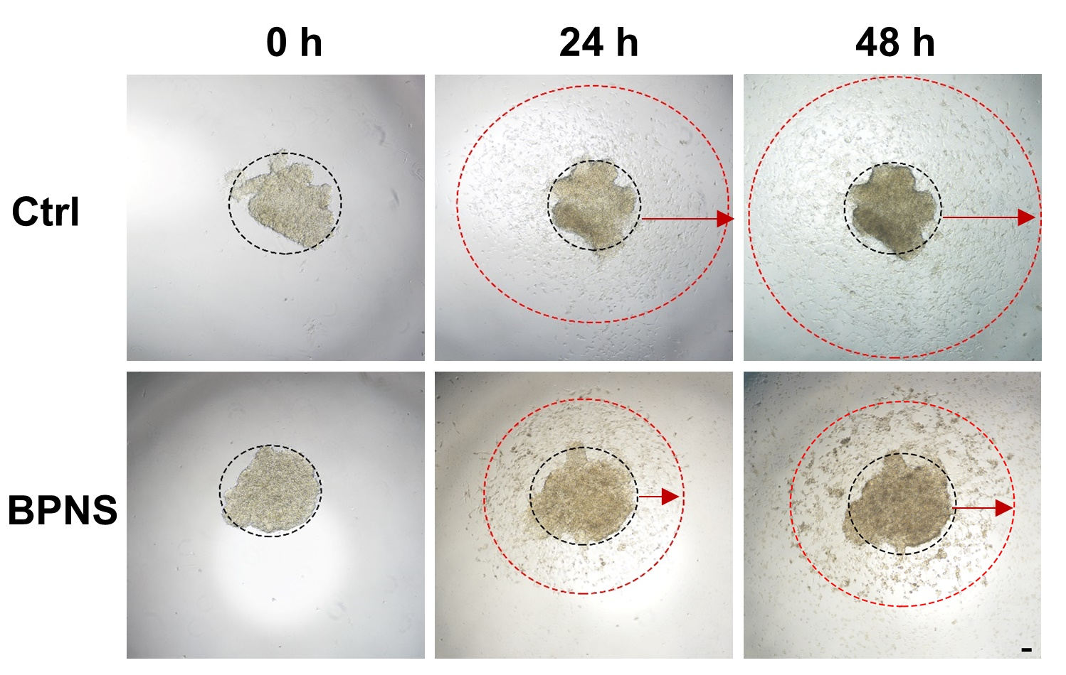

**Fig. S5** The3D cell spheroid invasion assay results of U251-MG cells after being treated with BPNS for 24 h and 48 h. Scale bar: 100 μm.

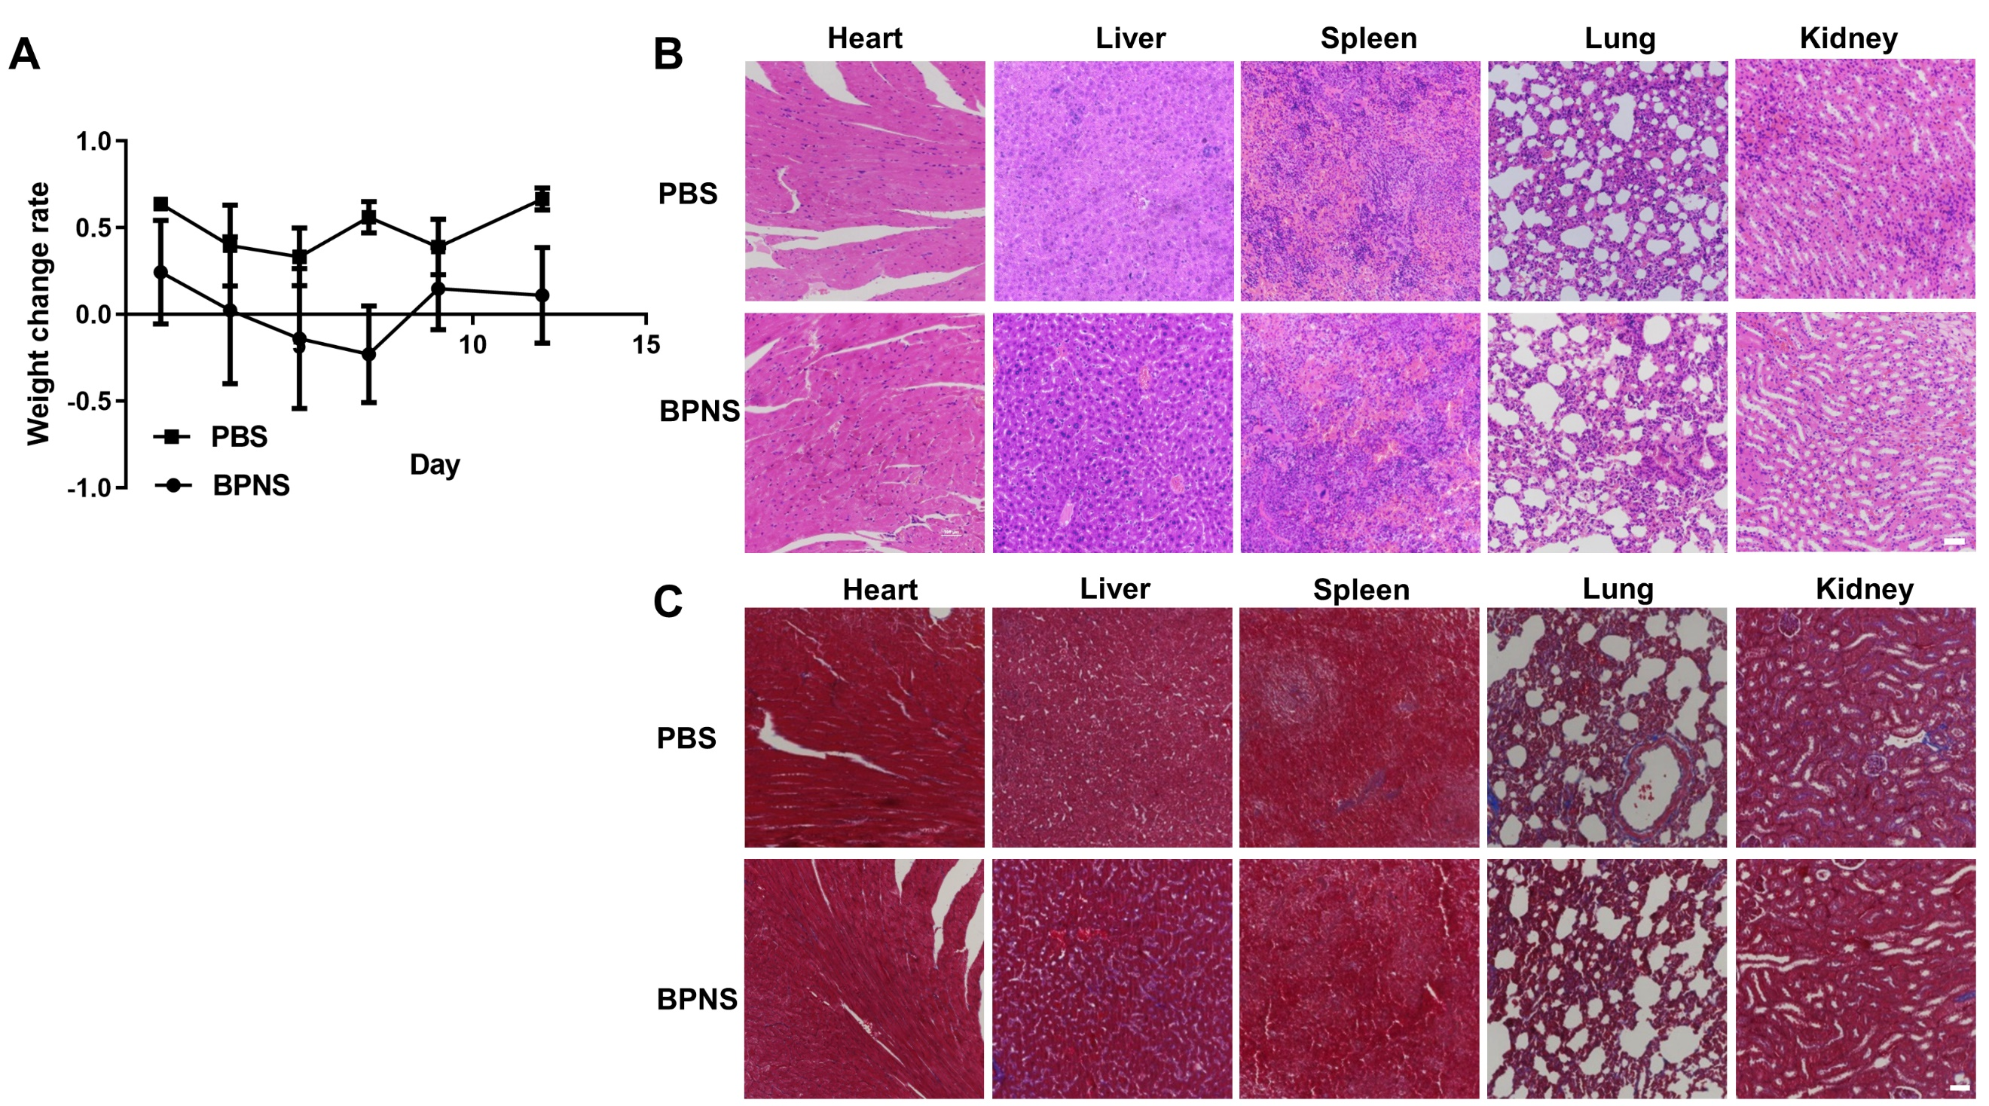

**Fig. S6** (**A**) The statistical chart of the weight changes of the PBS and BPNS group of nude mice.(**B**) Theresults of H&E staining of main organs in PBS and BPNS-treated group, *n* = 3. (**C**) Theresults of MASSON staining of main organs in PBS and BPNS-treated group. Scale bar: 100 μm.



**Fig. S7 (A**) Healthy mice were intravenously injected with BPNS and PBS separately, and then irradiated with NIR (1 W/cm2). The brain temperature was monitored using a thermal imager to ensure that BPNS crossed the BBB. After obtaining the mice's brains, under NIR (1 W/cm2) irradiation, the brain temperature of mice in the BPNS+NIR group was significantly higher than that of the control group, indicating that BPNS successfully crossed the BBB and remained in the brain with the assistance of NIR. (**B**) The living fluorescent imaging of the mouse after BPNS labeled with IR780 to verify whether BPNS could cross BBB in different groups: Ctrl, BPNS-IR780, BPNS-IR780 + NIR. (**C**) The H&E staining results of brain in different experimental groups showed that NIR-assisted BPNS crossing the BBB would not cause pathological damage to the brain. (**D**) The cell viability of GL261 cells was assessed using CCK-8 assay after treatment with BPNS, and irradiated with NIR (1 W/cm2), *n* = 5. Scale bar: 100 μm.

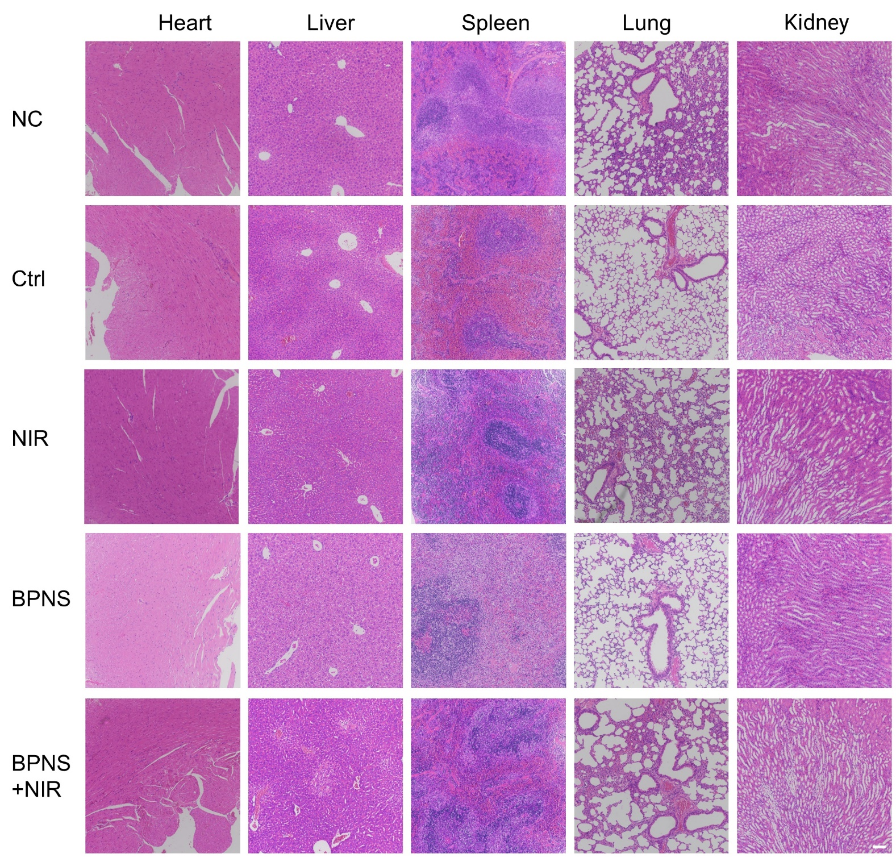

**Fig. S8** TheH&E staining of major organs in different treatment groups (Normal control, Ctrl group, NIR group, BPNS, and BPNS+NIR group) of orthotopic glioma. Scale bar: 100 μm.

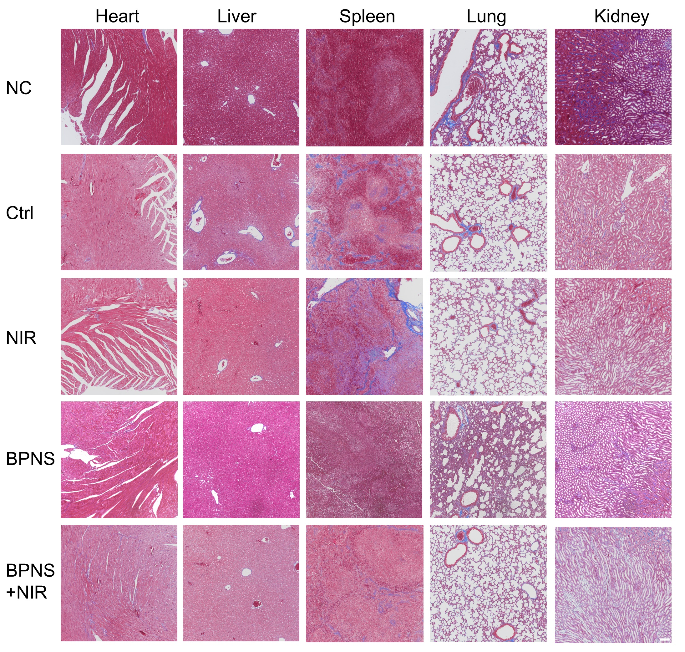

**Fig. S9** TheMASSON staining of major organs in different treatment groups. Scale bar: 100 μm.



**Fig. S10** Thechanges in the protein levels of *WNT/β-catenin* signaling pathway-related proteins and transcription factors. (A-B) Protein level changes and semi-quantitative analysis of WNT 5A/B in U87-MG cells after BPNS treatment. (C-D) Protein level changes and semi-quantitative analysis of TCF 4 in U87-MG cells after BPNS treatment. Error bar, mean ± SD, *n* = 6, \*\**P* < 0.01, \*\*\**P* < 0.001.



**Fig. S11** BPNS down-regulated protein expression in *WNT/β-catenin* and *NOTCH* signal pathway of GL261 and U251-MG cells. (**A**) The western blot results of p-GSK-3β, β-catenin, Hes1, Notch1, and Jag1 of GL261 cells after being treated with BPNS for 24 h. (**B**) The western blot results of p-GSK-3β, β-catenin, CD44 of U251-MG cells after being treated with BPNS for 24 h. (**C**) The western blot results of Notch1, Hes1 of U251-MG cells after being treated with BPNS for 24 h.



**Fig. S12** (**A**) Immunohistochemical staining results of CD31 in orthotopic tumor tissue sections. Scale bar: 50 μm.



**Fig. S13** RNA-Sequencing statistical data graph of *GSK-3β* (**A**) and *β-catenin* (**B**), *n* = 4.



**Fig. S14** The impact of *WNT/β-catenin* signaling pathway activators on the *NOTCH* signaling pathway was examined. (**A**) The protein level changes of Notch 1 and HES 1 after different treatments (Ctrl, BPNS, LiCl, BPNS + LiCl). (**B**) The quantification statistical graph of the protein level changes of Notch 1. Error bar, mean ± SD, *n* = 3, \**P* < 0.05, \*\**P* < 0.01, \*\*\**P* < 0.001.



**Fig. S15** The results of colocalization analysis. (**A**) The colocalization map analysis of fluorescent molecules C6 and CSNK2A2 in the control group. (**B**) The colocalization map analysis of BPNS-C6 and CSNK2A2 (R: CSNK2A2, G: BPNS-C6).



**Fig. S16** (**A**) RNA-Sequencing statistical data graph of CSNK2A2, *n* = 4. (**B**) The qRT-PCR results of *CSNK2A2*, *n* = 3***.***

**Supplementary Table**

**Table S1** Theinformation of primary and secondary antibodies.

|  |  |
| --- | --- |
| Antibodies | Source |
| 1. anti-c-myc (WB)  2. anti-cyclin D1 (WB)  3. anti-cyclin D3 (WB)  4. anti-Sox 2 (WB)  5. anti-Jagged1 (WB)  6. anti-Hes 1 (WB)  7. anti-Notch 1 (WB and IF) | Santa Cruz Biotechnology  Santa Cruz Biotechnology  Santa Cruz Biotechnology  Santa Cruz Biotechnology  Santa Cruz Biotechnology  Cell Signaling Technology  Cell Signaling Technology |
| 8. anti-β-catenin (WB and IF) | R&D System |
| 9. anti-GSK-3β (WB) | Zen BioScience (221162) |
| 10. anti-p-GSK-3β (S21/S9) (WB) | R&D System |
| 11. anti-p-β-catenin (Ser33) (WB)  12. anti-CD44 (WB and IF)  13. anti-GAPDH (WB)  14. anti-CD31 (IHC) | Zen BioScience (310053)  Cell Signaling Technology  Cell Signaling Technology  ServiceBio (GB113151) |
| 15. anti-Rabbit-HRP  16. anti-Mouse-HRP  17. anti-CSNK2A2  18. anti-WNT5A/B  19. anti-TCF4  20. Donkey anti-Rabbit IgG (H+L) Highly Cross-Adsorbed Secondary Antibody, Alexa Fluor™ Plus 594  21. Donkey anti-Mouse IgG (H+L) Highly Cross-Adsorbed Secondary Antibody, Alexa Fluor™ Plus 488 | SAB  SAB  Proteintech  Proteintech  Proteintech  Invitrogen  Invitrogen |

**Table S2** Primers described in the article.

|  |  |  |
| --- | --- | --- |
| Gene | Forward primer sequence 5’→3’ | Reverse primer sequence 5’→3’ |
| *Sox2* | 5’-GCCGAGTGGAAACTTTTGTCG-3’ | 5’-GGCAGCGTGTACTTATCCTTCT-3’ |
| *c-Myc* | 5’-GGCTCCTGGCAAAAGGTCA-3’ | 5’-CTGCGTAGTTGTGCTGATGT-3’ |
| *Axin2* | 5’-TACACTCCTTATTGGGCGATCA-3’ | 5’-TTGGCTACTCGTAAAGTTTTGGT-3’ |
| *cyclin D1* | 5’-GCTGCGAAGTGGAAACCATC-3’ | 5’-CCTCCTTCTGCACACATTTGAA-3’ |
| *Notch1* | 5’-GAGGCGTGGCAGACTATGC-3’ | 5’-CTTGTACTCCGTCAGCGTGA-3’ |
| *Hes1* | 5’-TCAACACGACACCGGATAAAC-3’ | 5’-GCCGCGAGCTATCTTTCTTCA-3 |
| *β-catenin* | 5’- CATCTACACAGTTTGATGCTGCT -3’ | 5’- GCAGTTTTGTCAGTTCAGGGA -3’ |
| *GSK-3β* | 5’- GGCAGCATGAAAGTTAGCAGA -3’ | 5’- GGCGACCAGTTCTCCTGAATC -3’ |
| *ZEB 1* | 5’-CGCTCTACTAAGGAGGCTGC-3’ | 5’-GAACCGGGATGGGAAGTGAC-3’ |
| *Jagged1* | 5’-GTCCATGCAGAACGTGAACG-3’ | 5’ GCGGGACTGATACTCCTTGA-3’ |
| *DDR 1* | 5’-TGCCAGCTTCTCCTTGTTCT-3’ | 5’-CGCCGTTCTCCATGTAGTCA-3’ |
| *DDR2* | 5’-TTAACGGCTGCTTTCTGACC-3’ | 5’-AGAGCTAGTGTTGAGTCAGTGT-3’ |
| *COL5A2* | 5’-AGCTGGGACCATCCCAAAAG-3’ | 5’-CCACTGACATGACAAAAGCGT-3’ |
| *COL1A2* | 5’-AGGGGTCTCCATGGTGAGTT-3’ | 5’-CCTCGGCTTCCAATAGGACC-3’ |
| *COL4A5* | 5’-TTCTCCTGAGAGACCGGCTT-3’ | 5’-GACAGTGAGGCTTGGGTGAA-3’ |
| *COL4A6* | 5’-CCAGCTGCTCACAGAACAGA-3’ | 5’-AGGCACAACGTAACCAGGAG-3’ |
| *FURIN* | 5’-CCTGGTTGCTATGGGTGGTAG-3’ | 5’-AAGTGGTAATAGTCCCCGAAGA-3’ |
| *MMP 1* | 5’-AAAATTACACGCCAGATTTGCC-3’ | 5’-GGTGTGACATTACTCCAGAGTTG-3’ |
| *MMP 2* | 5’-TACAGGATCATTGGCTACACACC-3’ | 5’-GGTCACATCGCTCCAGACT-3’ |
| *PRKCA* | 5’-GTCCACAAGAGGTGCCATGAA-3’ | 5’-AAGGTGGGGCTTCCGTAAGT-3’ |
| *SH3PXD2A* | 5’-GGACCCCAAGCAAAGGATCAT-3’ | 5’-TGCCCGGCAGTATTCATCG-3’ |
| *TIMP 2* | 5’-AAGCGGTCAGTGAGAAGGAAG-3’ | 5’-GGGGCCGTGTAGATAAACTCTAT-3’ |
| *BMI1* | 5’-TGGACTGACAAATGCTGGAGA-3’ | 5’-GAAGATTGGTGGTTACCGCTG-3’ |
| *CALM1* | 5’-TTGACTTCCCCGAATTTTTGACT-3’ | 5’-GGAATGCCTCACGGATTTCTT-3’ |
| *ADAM12* | 5’-TCTCATTGCCAGCAGTTTCAC-3’ | 5’-CGTGTAATTTCGAGCGAGGG-3’ |
| *ADAM19* | 5’-GGGAGCCTGGATGGACAAG-3’ | 5’-AGCTTTGAGTGGATGCTTTTCTC-3’ |
| *MMP 14* | 5’-GGCTACAGCAATATGGCTACC-3’ | 5’-GATGGCCGCTGAGAGTGAC-3’ |
| *MMP 15* | 5’-AGGTCCATGCCGAGAACTG-3’ | 5’-GTCTCTTCGTCGAGCACACC-3’ |
| *MMP 16* | 5’-AGCACTGGAAGACGGTTGG-3’ | 5’-CTCCGTTCCGCAGACTGTA-3’ |
| *MMP 17* | 5’-CACTCATGTACTACGCCCTCA-3’ | 5’-TGGAGAAGTCGATCTGGATGTC-3’ |
| *MAPK 1* | 5’-TCTGGAGCAGTATTACGACCC-3’ | 5’-CTGGCTGGAATCTAGCAGTCT-3’ |
| *CD44* | 5’-CATTTCAACCACACCACGGG-3’ | 5’-AGCAGTGGTGCCATTTCTGT-3’ |
| *GAPDH* | 5’-GGAGCGAGATCCCTCCAAAAT-3’ | 5’-GGCTGTTGTCATACTTCTCATGG-3’ |
| *CSNK2A2* | 5’-TCCCGAGCTGGGGTAATCAA-3’ | 5’-GTTCCACCACGAAGGTTCTCC-3’ |